ATRIAL FIBRILLATION

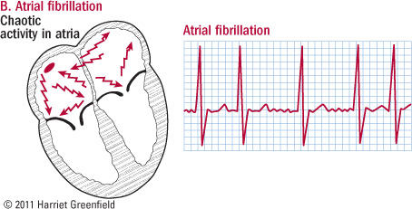

What Makes a Normal Heart Beat?
The heart is a large muscle with four chambers. There are left and right top chambers (called “atria”) and left and right bottom chambers (called “ventricles”). These chambers fill with blood from the body and then contract to circulate poorly oxygenated blood to the lungs, and then deliver well-oxygenated blood to the body.
The heart muscles contract after they are stimulated by an electrical impulse. A small area of special tissue in the right atrium called the sinus node starts an electrical impulse that will eventually travel down specialized electrical tracts. The sinus node controls the heart rate.
The electrical impulses cause the heart to contract in a coordinated fashion: the atria contract first and push blood into the ventricles; then the ventricles contract and push blood to either the lungs or the rest of the body. This electrical impulse can be recorded on an electrocardiogram (ECG or EKG).
What is Atrial Fibrillation?
Atrial fibrillation (sometimes called “A fib” or AF) is a type of irregular heart rhythm (called “arrhythmia:”) that affects the top chambers (atria) of the heart. Instead of the sinus node starting the electrical signal, the atria develop the ability to send out electrical impulses on their own, in a rapid, disorganized manner. These rapid and disorganized impulses cause the atrial muscle to quiver or fibrillate, instead of contracting in an organized, structured fashion. A specialized region of tissue between the atria and ventricles, called the AV node, is able to filter some of these impulses, however, the number of impulses that pass through the filter is usually abnormally high. The pattern with which these abnormal atrial impulses are conducted through the AV node is therefore fast and irregular.

What Causes Atrial Fibrillation?
Most commonly, Atrial Fibrillation (AF) occurs secondary to structural disease. In giant breeds such as Great Danes and Irish Wolfhounds, AF can occur without underlying heart disease – in which case the AF is called “lone” Atrial Fibrillation.
Common heart diseases associated with AF are severe mitral regurgitation (MR) and dilated cardiomyopathy (DCM).
How Is Atrial Fibrillation Diagnosed?
Atrial Fibrillation is usually suspected based on physical examination. Your veterinarian may hear a fast and irregular heart rhythm, and recommend further tests with a cardiologist.
Atrial Fibrillation is diagnosed by performing an electrocardiogram (ECG or EKG). Typically an echocardiogram (heart ultrasound) will be recommended to determine whether there is any evidence of structural disease.
In some cases, a Holter monitor (24 hour ECG) may also be recommended to better assess your pet’s rhythm over the course of the day.
How Is Atrial Fibrillation Treated?
Typically, Atrial Fibrillation is treated medically. The goal of medical treatment is to lower the fast heart rate associated with AF. In some cases, medical treatment can also result in a return to a normal (sinus) rhythm. Commonly used medications include:
- Diltiazem
- Digoxin
- Atenolol or Sotalol
- Amiodarone
In some cases, especially when structural disease is not present, electrocardioversion may also be considered. The purpose of electrocardioversion is to convert the irregular rhythm back to a normal (sinus) rhythm.
In most cases, atrial fibrillation can be well managed. Most pets tolerate atrial fibrillation well, and can still maintain a good quality of life. Regular check ups will be an important part of managing your pet’s heart disease.

